Activity 2: UML Diagram Design Project
1. Project Title
“The Daily Grind Ordering System”
System Description
The The Daily Grind Ordering System is a specialized digital platform designed to modernize the interaction between customers and staff within a busy café environment. The system enables customers to browse a comprehensive digital menu, select their preferred beverages, and apply detailed customizations such as milk alternatives, sweetness levels, and additional espresso shots. By digitizing the order intake process, the system minimizes human error during verbal communication and ensures that every drink is prepared exactly to the customer's specifications.
Behind the counter, the system serves as a central hub for operational efficiency. It provides baristas with a real-time order queue that updates as transactions are processed, allowing for better workflow management and reduced wait times. For the management team, the system includes integrated inventory tracking that monitors ingredient usage and alerts staff when supplies are low. This holistic approach ensures a seamless experience from the moment a customer enters the shop until their order is served.
Actors / Users
- Customer: The primary external user who interacts with the digital menu, places orders, and completes payments.
- Barista/ Staff: The staff member responsible for fulfilling orders, managing the preparation queue, and updating order statuses.
- Store Manager / Admin: The administrative user who manages the digital menu, monitors inventory levels, and accesses sales and performance reports.
Main System Functions
- Menu Management: Allows administrators to add, update, or remove menu items and prices in real-time.
- Order Placement & Customization: Enables customers to select items and specify unique drink preferences before finalizing an order.
- Payment Processing: Securely handles financial transactions via integrated payment gateways or cash-on-counter options.
- Order Fulfillment Tracking: Provides a real-time queue for baristas to track "Pending," "Preparing," and "Completed" statuses.
- Inventory Monitoring: Automatically tracks ingredient stock based on orders placed and generates alerts for low supplies.
UML Use Case Diagram
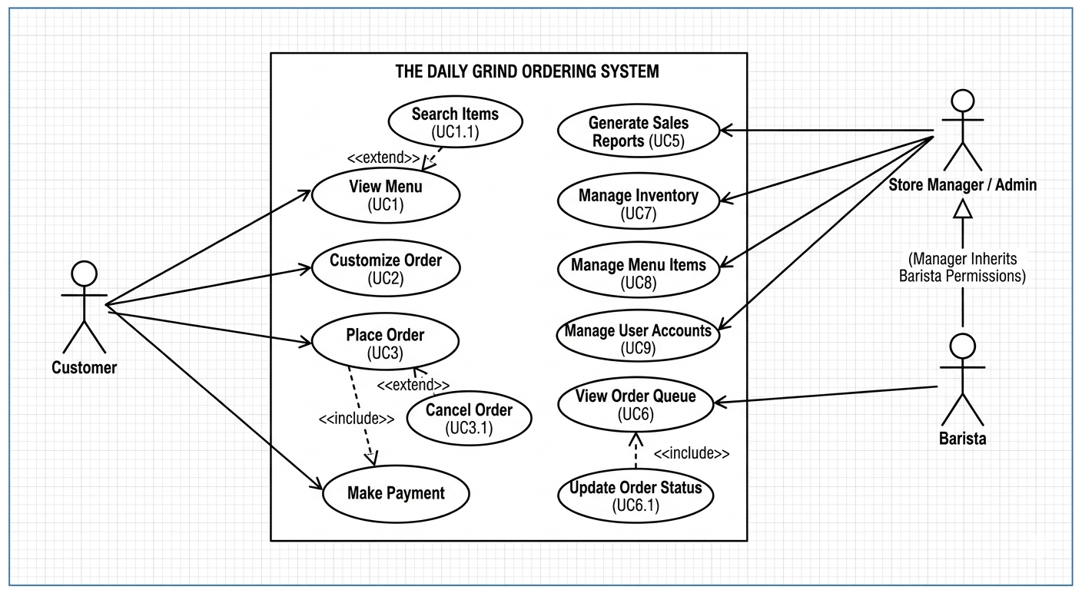
Short Explanation
This Use Case Diagram illustrates the functional requirements of The Daily Grind Ordering System by mapping the interactions between the primary actors and the core system modules. It clearly defines the system boundary, showing how the Customer initiates the ordering process, while the Barista and Manager handle the operational and administrative backend. The inclusion of relationships like "Make Payment" within the ordering flow ensures that the business logic is complete and reflects a secure, end-to-end transaction.

